How to Upload Contacts by CSV File
What is a CSV File?
A CSV, or comma-separated values, is a type of file that allows you to enter data in a table-structured format or spreadsheet. You will need a program like Microsoft Excel or Windows Notepad to create the file to upload in your Participant Center.

If you have a lot of email contacts that you’d like to migrate into your Participant Center, creating a CSV file for upload may be easier and save you time instead of manually entering each email contact.

NOTE: Yahoo and Gmail email users can directly import their contacts into the Participant Center without using a CSV file. View the separate help document for how to complete this action.
Step-1 Prepare your CSV file
- Export your contacts list or address book from your email service that you use (follow your service provider’s instructions to complete this step)
- Create a new CSV file using a text editor (such as Microsoft Windows Notepad) or a spreadsheet application (such as Microsoft Excel) that lets you save a document as a .CSV file type.
- Create three column headings: First, Last, Email
- Then, on the subsequent lines, enter the first name, last name and email address of each contact. (You can copy and paste this from the export that you did in Step 1 A.
For example, your document would look like:
First, Last, Email
Jane, Smith, janesmith@email.com
John, Smith, johnsmith@email.com
STEP 2- Login to your Participant Center

-CONTINUE ON NEXT PAGE-

STEP 3- On your Participant Center home page and click the “Email” tab to access the Email functionality.
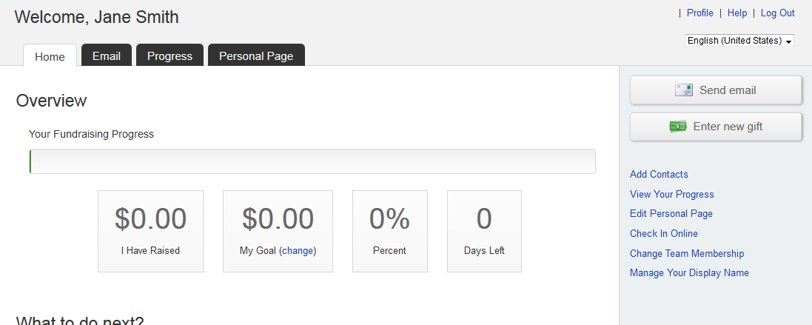
STEP 4-Click “Contacts” in the links on the right-side of the screen. 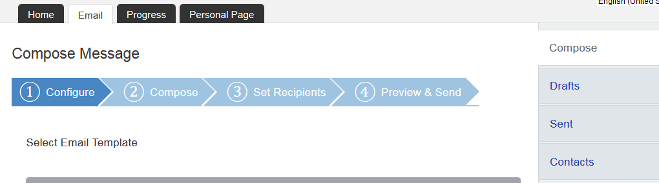
-CONTINUE ON NEXT PAGE-

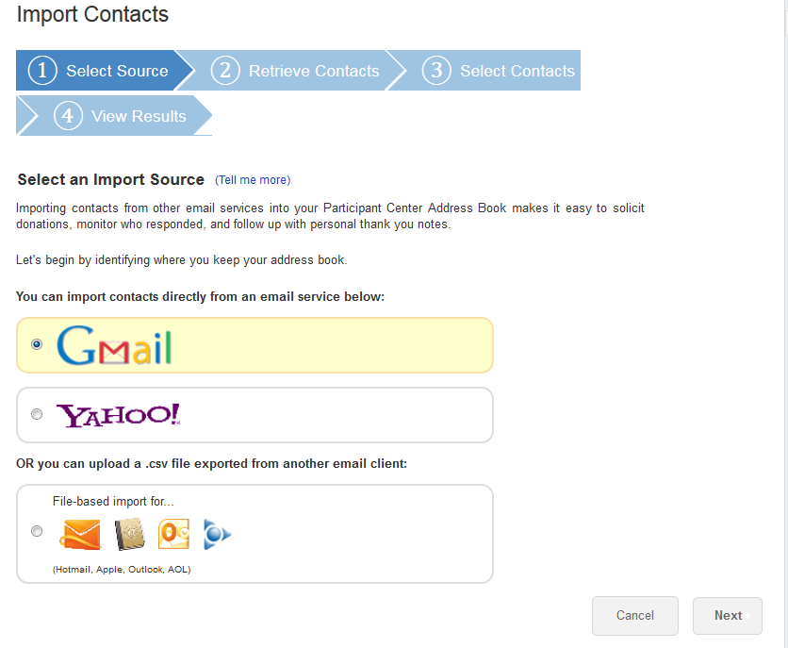
STEP 5- Click “Import Contacts” 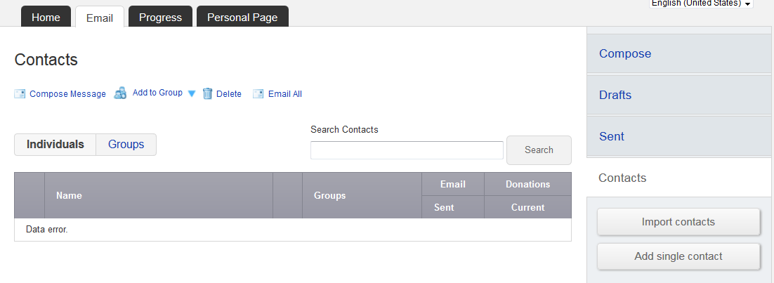STEP 6-Choose the button next to “File-based import for…”
-CONTINUE ON NEXT PAGE-

Next, browse your computer to find your prepared CSV file
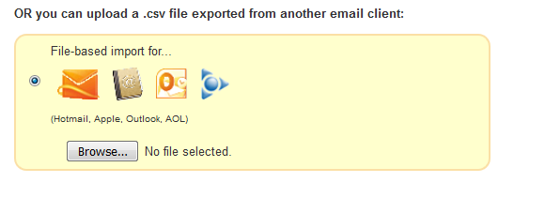
Once you select your file, you’ll see the file name on the screen.
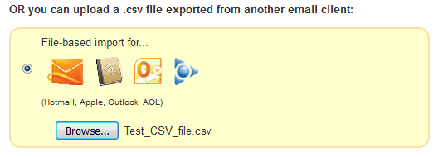
STEP 7- Click “Next” to continue
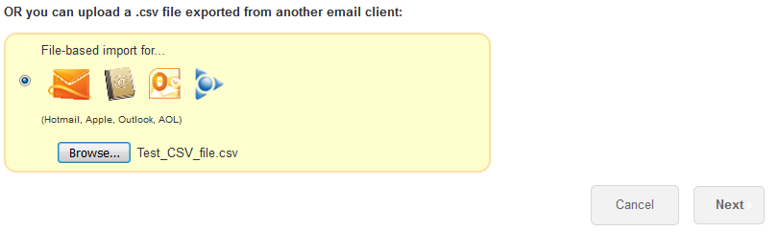
-CONTINUE ON NEXT PAGE-

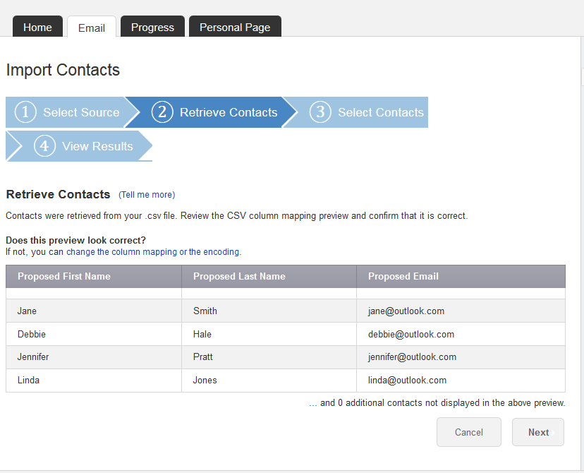
Step 8- Preview the contacts from your file and ensure they are mapped to the correct fields (i.e. first name, last name, email address). If you are satisfied with the results, click NEXT. If you need to adjust the mapping, click “change the column mapping” to fix.

-CONTINUE ON NEXT PAGE-

STEP 9- Select Contacts to Import
In most cases you’ll want to import all of the contacts that are in your uploaded file. To do so, select the first radio button that says “Import all # contacts into your Participant Center Address Book.”
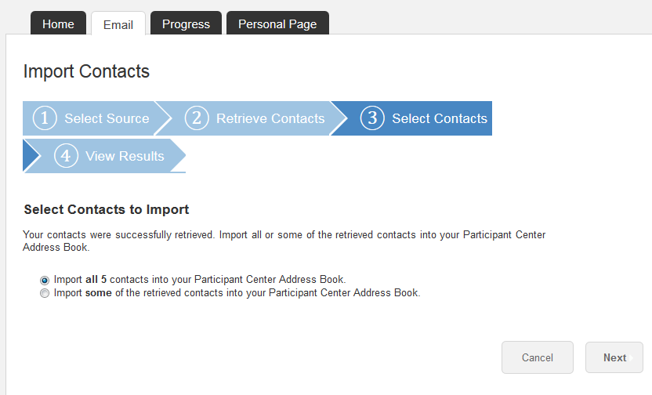

-CONTINUE ON NEXT PAGE-

Or…if you only want to select certain contacts to transfer over, check the “Select box” next to the individuals that you do want in your Participant Center contacts. 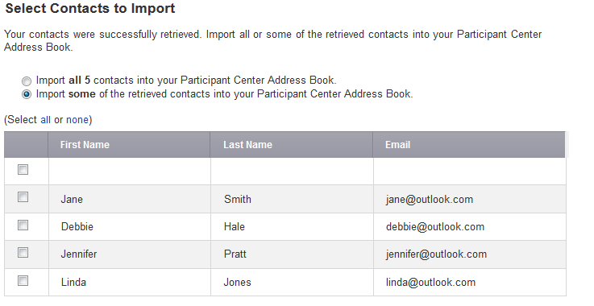

-CONTINUE ON NEXT PAGE-

STEP 10-SUCCESS! You will see a yellow text box showing how many of your contacts were successfully imported to your address book. Then, click “Finished” on the bottom of the page. You’re ready to start sending some emails!
